../../Downloads/thumbnail_open.png

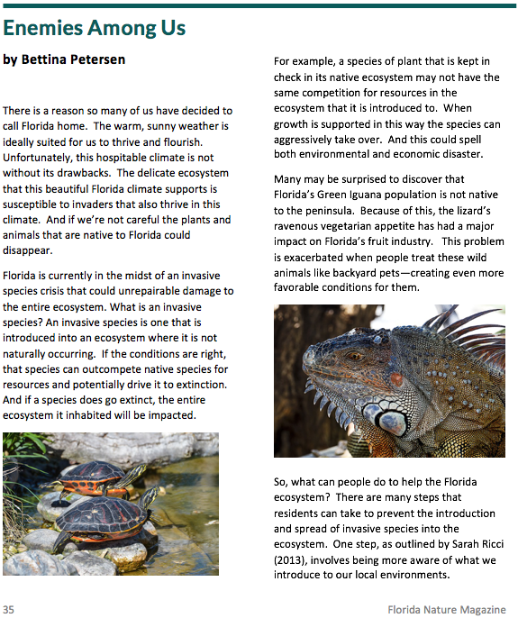

Article title

Author’s name

Page number

**36**